## Turing Test

* The Turing test, by definition is “A measure of determining whether a machine can demonstrate human intelligence in thoughts, words, or actions” as given by investopedia.com.
* This was first defined in one of Alan Turing's papers, “Computing Machinery and Intelligence”, from 1950 and is the basis of finding out if a conscious AI exists.
* The idea of a machine being able to think for itself began in 1936 when Turing built his first machine to model the human mind in Bletchley Park.
* This machines purpose was to crack the enigma code that was used by the Germans so the Allies could intercept their communications. However, it was not until 1950 when this paper had finally been published that these ideas became public knowledge, even though the paper was actually a successor to two pervious unpublished papers from 1947 and 1948. Due to these previous papers being unpublished, the 1950 paper was the first publicly obtainable work on the subject.
* The paper itself had been written in Manchester University’s computing laboratory
* which is the same location that the world’s first digital computer using stored programs was constructed.
* The paper made use of many other people’s ideas and concepts but Turing never referenced them in his paper. Examples of these people are Max Newman, a mathematician, and F.C.Williams who lead the team of engineers who both helped build the first universal machine. As well as the chemist and philosopher Michael Polanyi, and the zoologist and neurophysiologist J. Z. Young.
* All of these people had been involved in discussions such as a large interdisciplinary discussion that was held on the 27th October 1949 titled “the Mind and the Computing Machine”. This discussions purpose was to calm the public who was angered by his research, as Geoffery Johnson, a famous brain surgeon, had spoken out in 1949 against it in a lecture called “The Mind of a Mechanical Mind”.
* This lead to this discussion and Turing being quoted on that his research was only aimed at “finding out to what extent a machine could think for itself” as taken by the London Times. To find out this extent Turing proposed his “Imitation Game” now commonly known as the “Turing Test”.
* 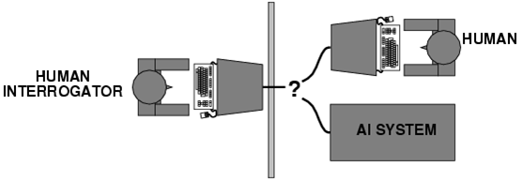The Turing Test is a way of determining whether a computer system can acquire abilities that may only be performed by something possessing human intelligence. T
* he test is performed with a computer and two humans, one human acts as the interrogator and the other is interrogated along with the computer. The interrogator at any time cannot know whether they are talking to a human or the computer and therefore must ask questions designed to help them determine whom they are talking with. This is as both the human and the computer shall be situated in a separate rooms from the interrogator and can only respond in text and not speech. This is the original idea of the imitation game as conceived by Turing, although since then there have been improvements and developments in its method.
* Although this test was first conceived almost 70 years ago, 25 years before the first personal computer was sold and almost 55 years before computers had 1GHz CPU’s, it is still widely used as the benchmark to of AI.
* This is as if an AI is able to pass the test the test it must possess human levels of intelligence or greater though this does present many major problems.
* One is that it can’t be used to test the intelligence of all AI as it sees if they possess Human abilities, for example you can’t ask AlphaGo “What did you have for breakfast?” as it can only answer in Go moves. If this is the case does this mean that AlphaGo is not that advanced as it can’t pass the Turing Test. Well this is not technically true as it just means the environment of the test has to be changed so instead of testing for human abilities you are testing for human weaknesses. This is where the Achilles heel of the test lies and why recently most machines and AI fail the test as soon as they’ve reached such a high level of advancement they are deemed super intelligent and therefore non-human. This is as humans always make small mistakes such as spelling errors or wrong moves.
* For example in the second game against Lee Sedo, AlphaGo played a move which made no sense and had never been played before which lead to Lee having to take 15 minutes to formulate a response. It’s this level of super intelligence that leads to AI failing the tests. This can also be taken in reverse as if a human is to play a strange move against an AI that most humans would see as stupid or maybe a trap an AI would react differently. This is as with the amount of computing power available it is easy to program intelligence, as it can easily be done through a machine learning algorithm, the difficulty comes from an AI developing human weaknesses such as making mistakes.

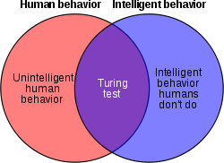

## Biliography:

<http://www.turing.org.uk/scrapbook/test.html>

<https://www.investopedia.com/terms/t/turing-test.asp>

<https://www.wired.com/2016/03/googles-ai-viewed-move-no-human-understand/>

<http://www.kccsoftware.com/kcchome/media/FirstTo1GHz.pdf>

<http://theemergingfuture.com/speed-technological-advancement.htm>

www.binarymove.com%2Fwhat-is-the-turing-test for fig.1

<https://www.shrm.org/hr-today/news/hr-magazine/0417/pages/recruiting-gets-smart-thanks-to-artificial-intelligence.aspx> for fig.2